AutoScanNT Advance Quick Reference

Scanning Images Page 1

Log on to The Scanner Terminal
If you ever need to re-boot the computer, then you will need to log-on. Windows will ask you to “Press CTRL ALT DELETE” to log-on
At the Log-on prompt:
Use the user ID :
Password : ********
Domain : ********

Start AutoScanNT
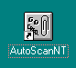

Click the AutoScanNT Icon on the windows Desktop OR
Click the Start Button → Programs and select AutoScanNT 2010 from the List.

Scan New Images

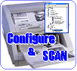
Always place the documents FACE up in the Canon Scanner.
Use this button when want to scan requests using a different configuration. AutoScanNT will tell you the current paper settings except when it first starts up.

Scan More New Images Using the Same Settings

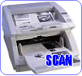
After you have scanned the first batch of requests, you can scan another batch of the same type by pressing the Scan More button.

Fixing Problems


After scanning a batch, you may encounter a few problems. To manually correct problems, use the Fix Problems button. (Common problems are missing barcodes, 2 or more barcodes failed barcode reads).

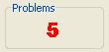
How to Fix Problems
For each image you will see a message describing the nature of the problem. In most cases, just enter the correct barcode number into the “Specify Image Name” window. For multiple barcodes, you can make a selection from the list OR select “ALL” to make a separate copy of the image for each barcode number.

AutoScanNT Quick Reference
Scanning Images Page 2

Fix Problem Buttons





Fix these problems later – go back to main menu
Fix this problem later – go on to the next problem
This image is not needed – discard it

Scanner Settings
When you click the SCAN button, you will be presented with the “CFM Scanner Interface Window” Please use the following settings when scanning forms:

Image/Paper size and location

Should be set to A4

Scan Parameters

Mode : Line Art Format : User Defined
Resolution : 300 Brightness : -40
Contrast : 0 Threshold : 10

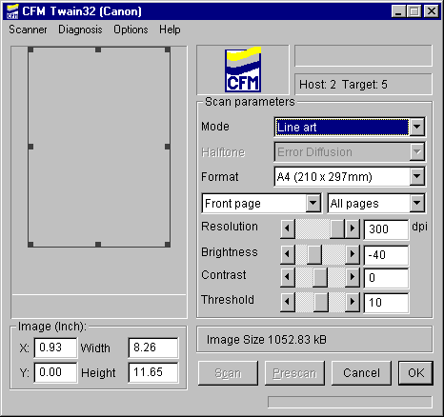

AutoScanNT Advance Quick Reference

Changing Media Page 1
AutoScanNT will warn you when you need to change the Media.

To completely verify and change the media may take more than an hour. You cannot scan during this process and remote images will not be processed. It is generally safe to wait for the end of the working day to change the disc so as not to disrupt work flow.
FINALISING MEDIA
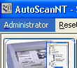
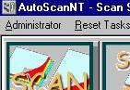

1. Check that all counters on the “Progress Panel” read Zero.

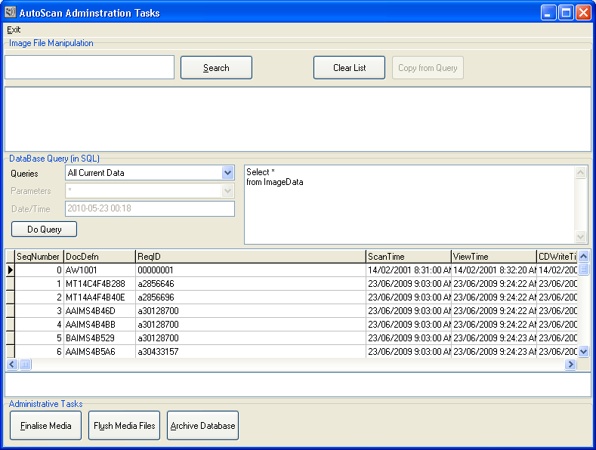

2. Change to the Administrator window by clicking on "Administrator" on the Menu bar (above the scan buttons).

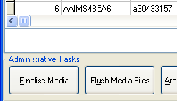

3. On the very bottom of the Administrator window is the Administrative Tasks Panel. Click "Finalise Media"

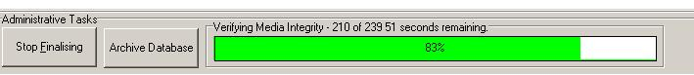
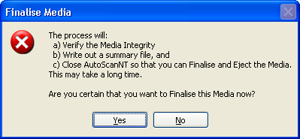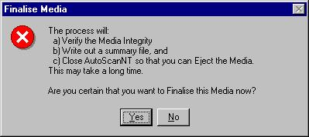
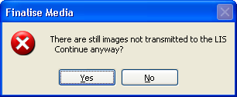
4. You may see a warning message if there are images not transmitted to the LIS.
5. Click "Yes" to the “are you sure” message to begin the finalisation process.
6. Accept the default Verification Level of 10%

7. The verification process will begin. You will see an indicator of progress and the time remaining to complete the verification process. This step can take 15 to 20 minutes for a CD and more than 1 hour for a DVD.

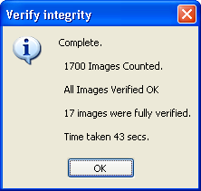
8. At the completion of the verification process, a report will be displayed. A successful verification is indicated by the "0 Images failed to verify message". See the user and administrator guides if you see a different message.

9. AutoScanNT will close. It is then safe to eject the media (see page 2).

AutoScanNT Advance Quick Reference

Changing Media Page 2

EJECTING A DISC (Windows 7)
1 The finalisation step page 1 will close AutoScanNT automatically. If AutoScanNT is still running ensure the verification step has been completed.

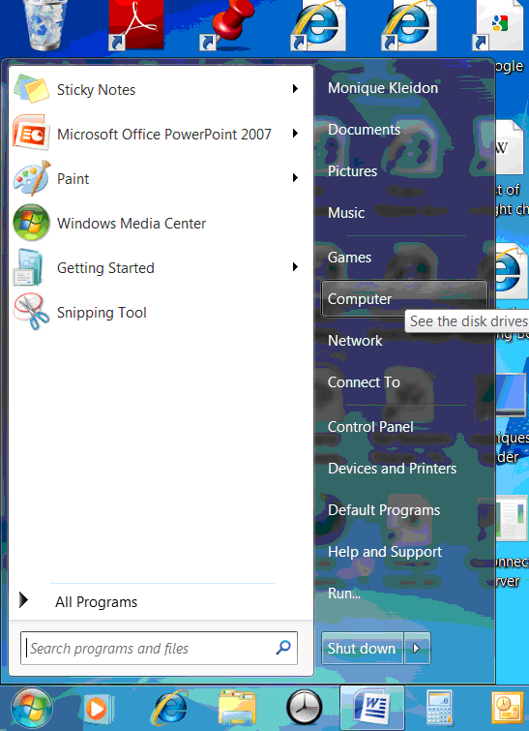
2. Click the Windows start button and select “Computer”

3. Right click on the Blu-Ray/DVD drive and select “Eject”

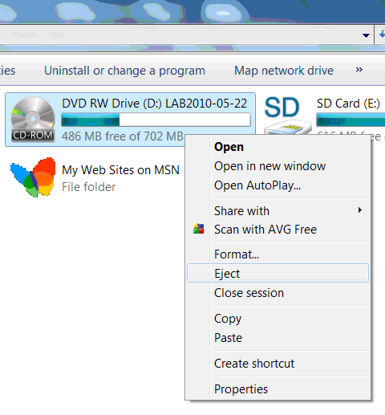

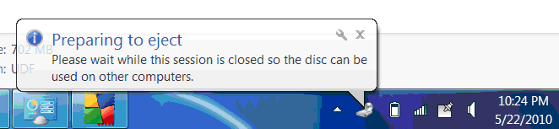
4. After clicking eject disc the “Preparing to eject” box will appear.

Note: This Disc Preparation message box will remain on screen during the process (about 2 minutes). The disc will automatically eject when finished.
AutoScanNT Advance Quick Reference
Changing Media Page 3
You must load a new CD or DVD before starting AutoScanNT. You will see error messages if you don’t.

1 Open a new DVD or CD and write the Label on it in Felt Marker Pen. Use the following format xxx_{year}{month}{day}. For example: if it is January 12, 2015 write lab20150112. (Writing year first makes it easier to list discs in chronological order)
2 Insert the disc into the drive and wait for about 10 seconds for it to spin up.

LOADING A MEDIA DISC AND ARCHIVING THE DATABASE

3 Click on the menu icon on the Roxio tool bar (near the computers clock) Select Format Disc.

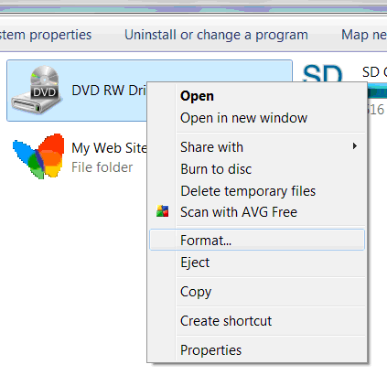
3 Open “Computer” and then right click the Blu-Ray/DVD and click “Format”

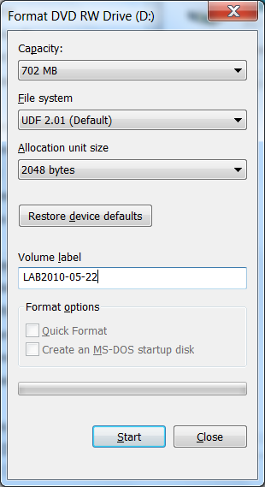
6. When the flashing has stopped Re-Start AutoScanNT in Administrator Mode. (Go to the Administrator window by clicking on “Administrator” on the Menu bar of the Main Window OR use the Admin Mode shortcut from the Program Menu).
5. Click START. The progress bars shows progress of formatting process
7. Click “Archive Database” on the administrative Tasks Panel. The process will take about 5 minutes.

8. When archiving is complete, AutoScanNT is ready to use. Return to the Main window by Clicking Exit on the Top Left of the Administrator window.
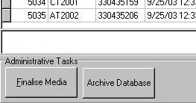
4 type the Name of the Disc into the Volume Label Field.

