Autoscan Quick Install for Barwon Health:
  - Administrators ONLY

Install the Program Files Folder:

With Administrator Privileges, Open the Folder
\\bhisilon-cifs\lrs\Images\installer\Quick Install\Program Files\
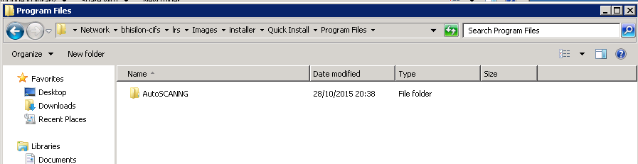
And Copy the AutoSCANG folder from that location TO
C:\program files\
OR
c:\program files (x86) \ (for 64 bit computers)

Install the SQL Server Client Driver
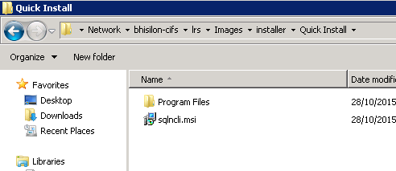
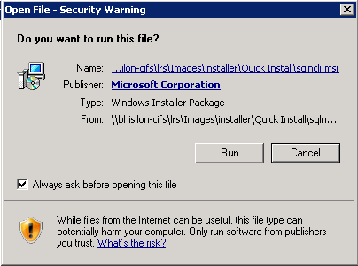
If you are on a 64 bit computer, you will need to run the 64 bit version of the SQL Client installer (from the Microsoft download website).
https://msdn.microsoft.com/en-us/sqlserver/ff658533

Create A desktop Shortcut.
In Users "Applications" Window, create a new shortcut to Autoscan NG

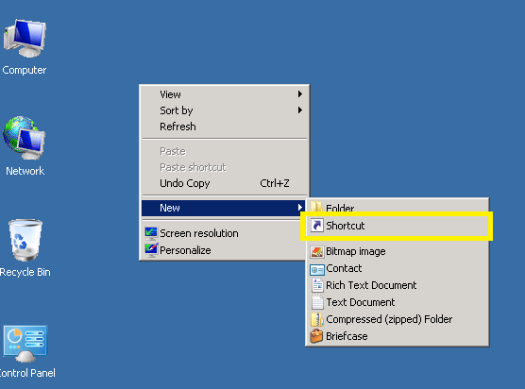
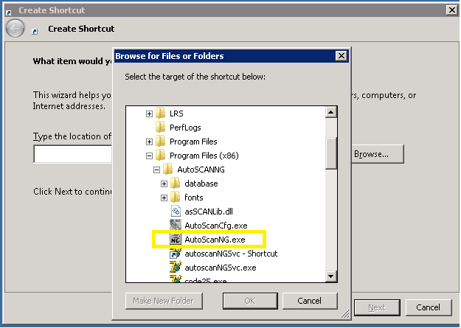

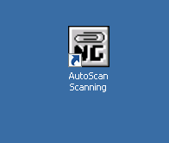
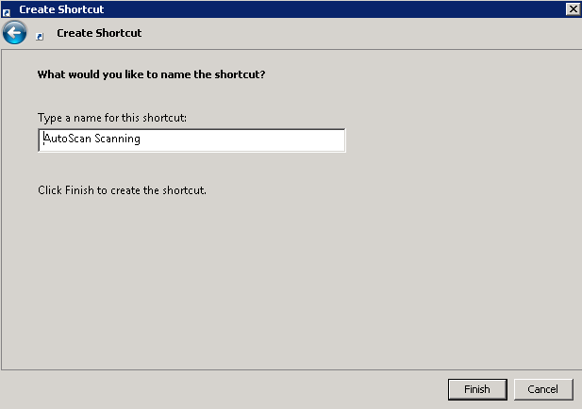

Start Autoscan and configure the Database Connection.

MAKE SURE THAT THE USER OF THE COMPUTER IS A MEMBER OF THE ONE OF THE AUTOSCAN DOMAIN GROUPS.
When you start Autoscan with no configuration installed, the Configuration utility will start automatically. This program requires escalated privileges so there MAY be a warning. There may also be a warning about "Data Provider could not be found" Close this message.
You must locate the Autoscan Configuration folder where AutoScan is expecting to find the DATABASE LINK FILE.
Change to the DIRECTORIES TAB to look at the SCAN Directories Folder, and Copy The folder name from the field (excluding the SCAN)
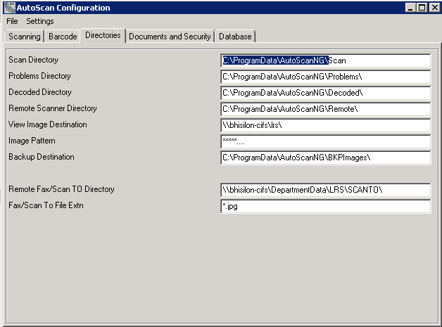
This might be different on different versions of windows.
OPEN the File location on the local computer and OVERWRITE the AUTOSCAN.UDL file that is present with the one from the QUICK INSTALL Folder.

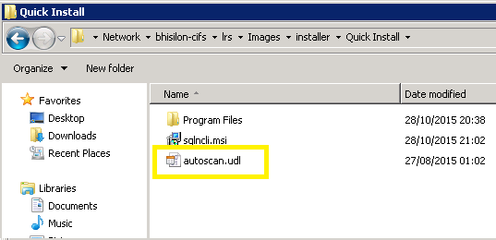
Also, if there is an Autoscan.inf file present, delete it.
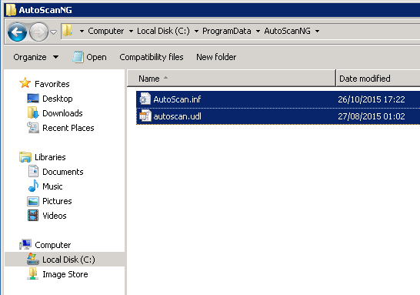
Leaving behind only the AUTOSCAN.UDL
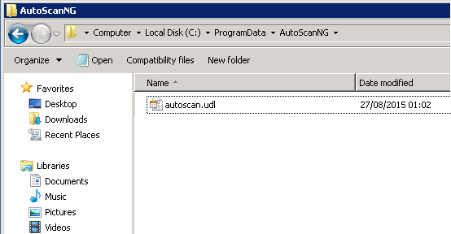

Set the Configuration and Check Permissions

CLOSE the Autoscan CONFIG program and RESTART AUTOSCAN.
Because Autoscan now has a valid Database Connection, the default SITE Level configuration will download from the database and be writing into the Autoscan Configuration Folder.
The CONFIG Program will OPEN again because the configuration is incomplete. Open the "General" tab

Confirm the Configuration
Confirm that the details have been populated with the details from the site. This should include a Reference to the PEER GROUP MEMBER in the Operating mode. If it does not, then the database connection is likely to have failed (does this user have permission to access the Database?) You could try copying the AUTOSCAN.INF file from another computer if this continues to be an issue.

Set the Scanner ID
Set the SCANNER ID to a 2 or 3 digit UNIQUE CODE. THIS MUST BE UNIQUE on the system. EG "Reception Workstation 1" might be called "RC1"
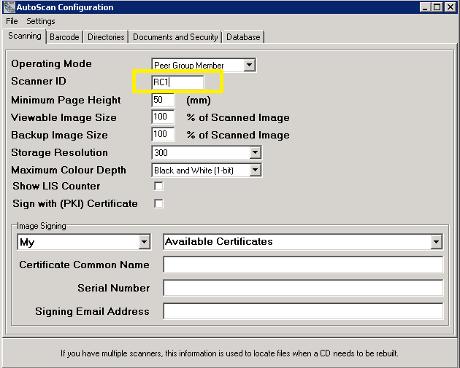

Create the Autoscan Temporary Folders
Click on FILE, SAVE from the Menu.
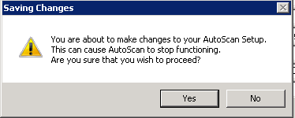
Answer "YES" to the Warning
And answer YES to each of the folder prompts
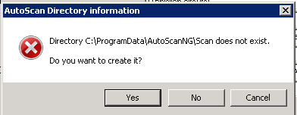
When the folders have been created, Autoscan Will prompt with
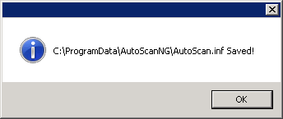
You will need to confirm that "ALL USERS" has read write priveleges on these newly created folders
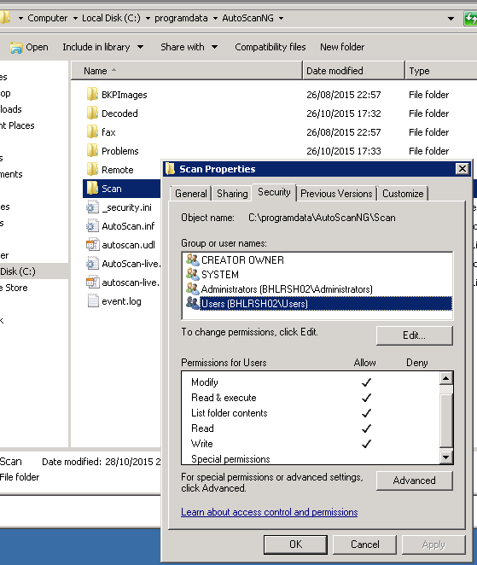
If All DOMAIN users don’t have write access to these folders, Autoscan will likely CRASH when starting.

Start Autoscan

Close all windows and stat Autoscan, you will be presented with the Autoscan Startup Screen and you are ready to scan.
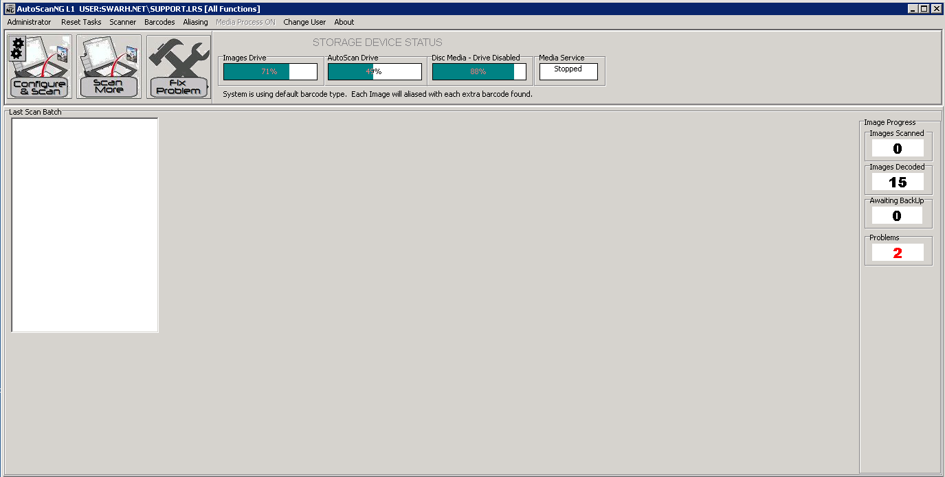

When you click SCAN for the First time, you will be presented with the LICENSE code prompt. Copy the code and send this to LRS Health who will supply you with a License code for this workstation.
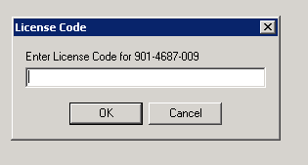
Installation is complete.

NOTES:

Windows XP
AutoscanNG will not support Domain Authentication on Windows XP and can only be used to SCAN directly from an attached Scanner. You should DISABLE FAX/SCAN TO in the configuration for windows XP computers by removing the folder setting.

Documentation and Downloads
The latest documentation and Downloads are located at:
http://www.galkam.com.au/autoscan/
You should start with the Autoscan User Guide, 2015.

